KAKURENBU

A Group Project

Presented to the Department of Computer Science

of the

University of San Carlos

In Partial Fulfillment

Of the Requirements of CS 131 Object-Oriented Concepts

Bachelor of Science in Computer Science

By

Echiverri, Louiz Vincent

Tan, Carl Stephen

Yazaki, Koichi

Ymbong, Michael Vincent

October 11, 2013

# Chapter 1 : Project Description

### What is the project all about

Our Project is a java based game of seek and destroy. It uses the latest of the JMonkey Engine, JMonkey Engine 3. The game is about seeking objects and shooting them with balls that if collide makes them disappear and if all is found or time runs out then its game over.

### Importance

Kakurenbu aims to show the java language’s capabilities and diversity of output by creating immersive 3d applications. It is also an exercise in showing the capabilities of the java language as a whole, while also showing how diverse a project could result into. By using the Jmonkey Engine, a java based game engine, filled with an expansive library of advance java based programming that can be easily accessible and understood even by java beginners. This shows how Java can be expansive to new minds and be able to share advance ideas through easily understood API’s. Kakurenbo is what beginners could achieve, a starting point towards bigger things as this project not only has allowed us to put into a concrete example what we have learned it also improve our java programming and see the real capabilities of this language.

# Chapter 2: Use Case Diagram



When a player first starts the program he first enters the start screen. In the start screen he is given the choice to start the game or end it. When the game starts the player has the option to move using the arrow keys or shoot using the space bar. The game continues until the timer ends or all balls have been shot. When either of these conditions are met then the program will proceed to the end screen, where the game stats are shown and the option to exit the program is given.

Chapter 3: User Interface Diagrams

### **Start Screen**

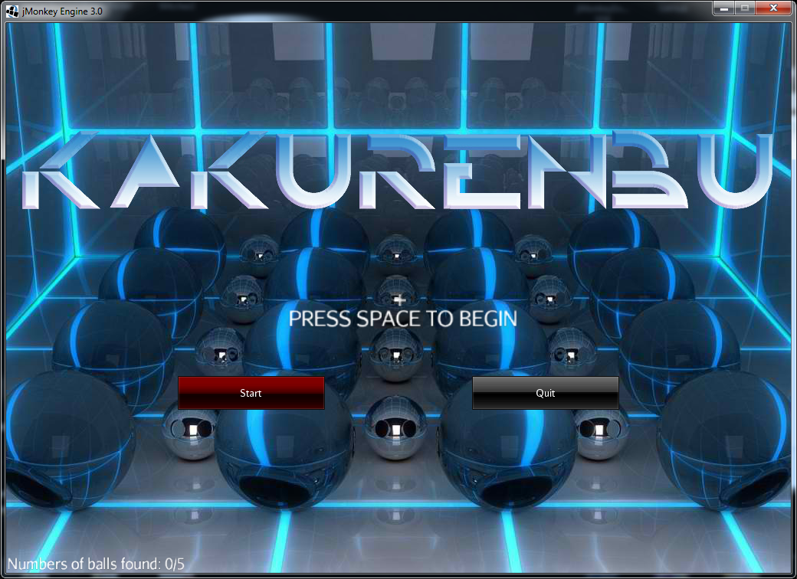

This is the start screen. This is the first screen that greets the user as he/she starts the program. There are two buttons on the screen, one to start the game and proceed to the next screen, another to exit the program. If the user presses enter then the program will proceed to the next screen but the game itself will not start. For that to happen the user has to press the spacebar button. If at any time the user presses the escape button while the program is active then it will close.

### In Game

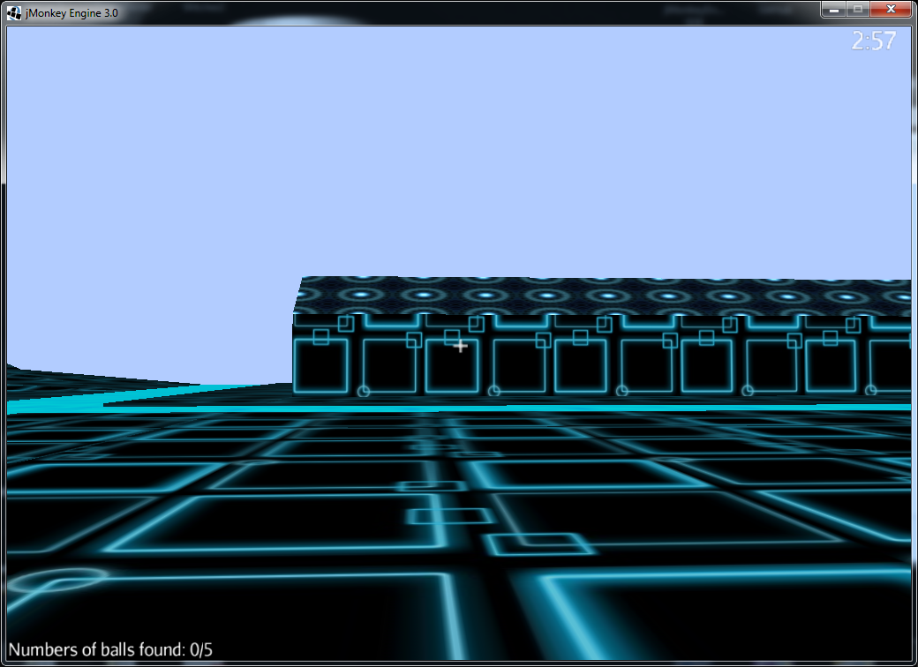

This is the in game screen that shows the user his/her movements and actions. The screen shows a first person view of the environment, which is set in a futuristic town. At the middle of the screen you will see a crosshair, which marks where the user is aiming. There is also a HUD, with displays at the bottom showing the number of balls found, and another at the top which shows the timer.

### Exit Screen

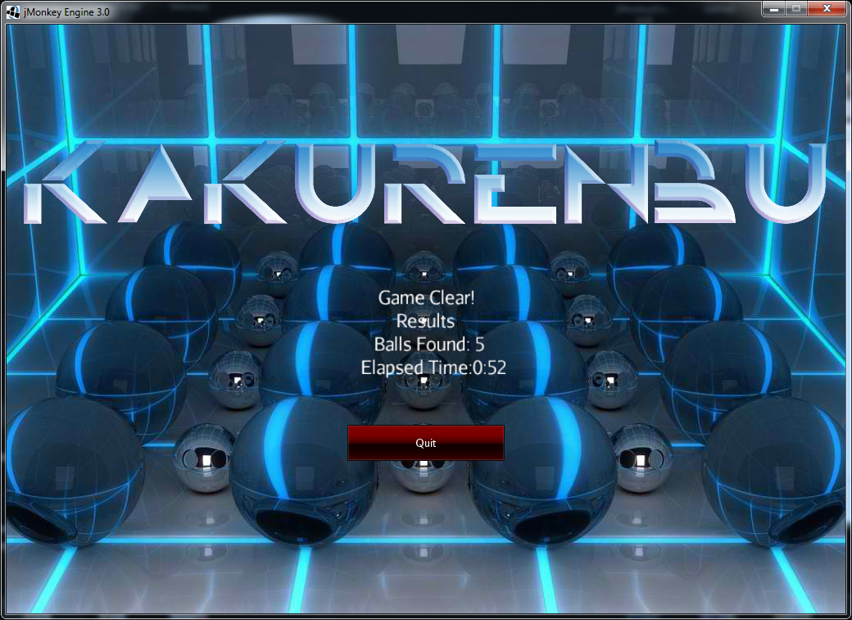

When the user has finished playing the game the program will proceed to the end screen. The end screen displays the game stats like the number of balls found as well as the time it took to complete the game. There is also a quit button that allows users to exit the program.

# APPENDIX

Please refer to included folder javadoc.

# Bibliography

Created using:

 



Jmonkey Engine <http://jmonkeyengine.org/>

Nifty-Gui <http://nifty-gui.lessvoid.com/>